2020-04-29

Assignment 3

CESG 506

Kristinn Hlíðar Grétarsson

# Problem 1

## Part 3

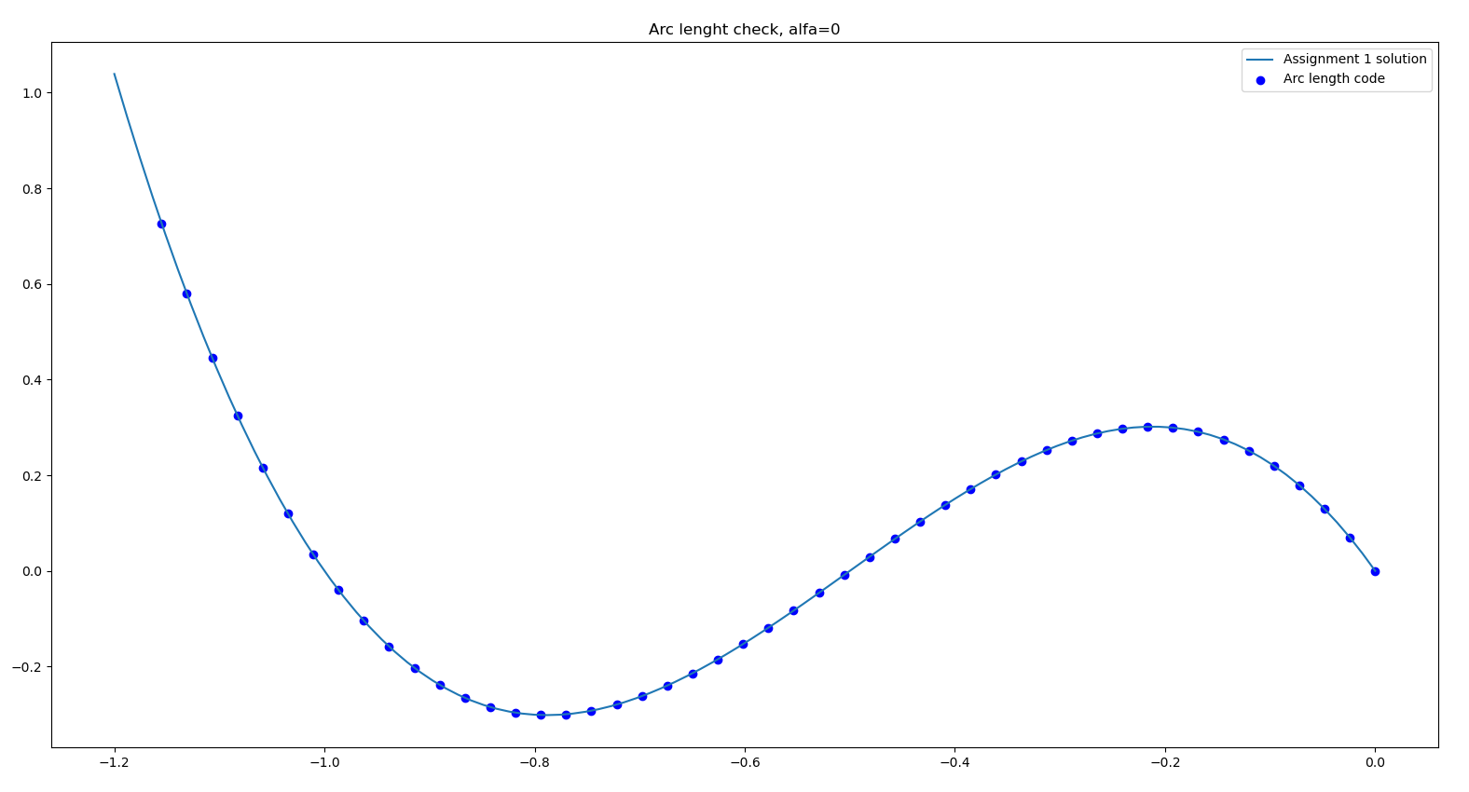

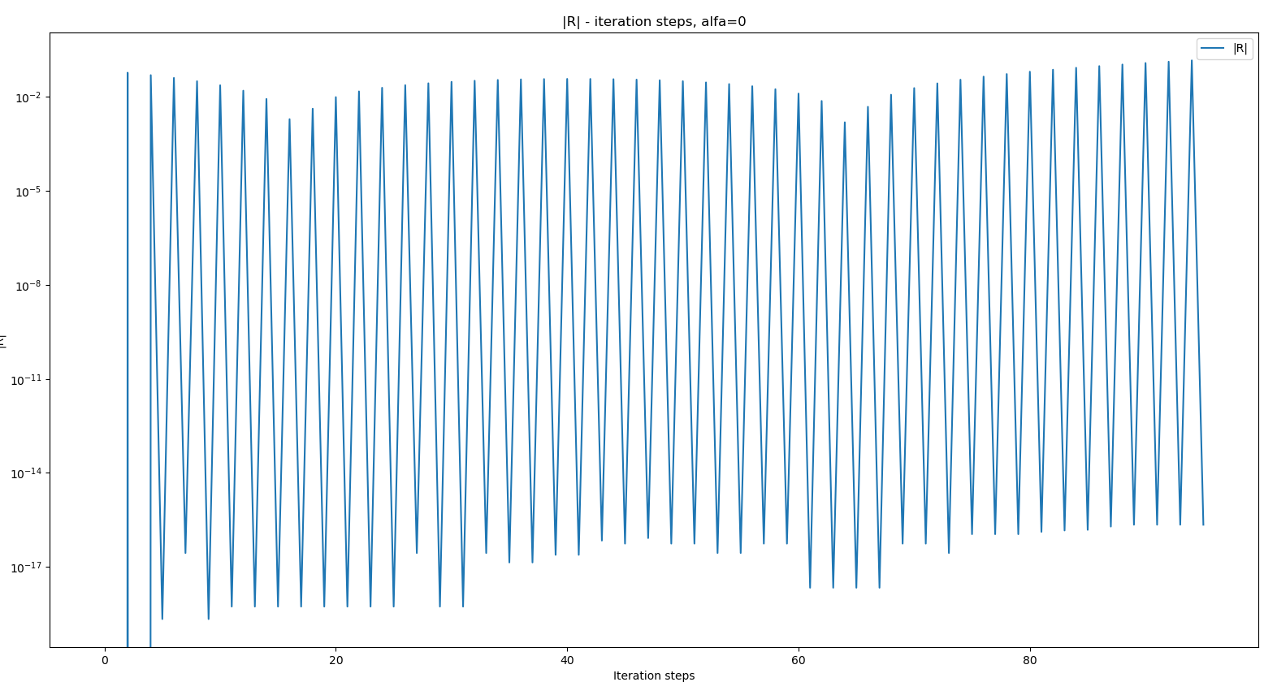

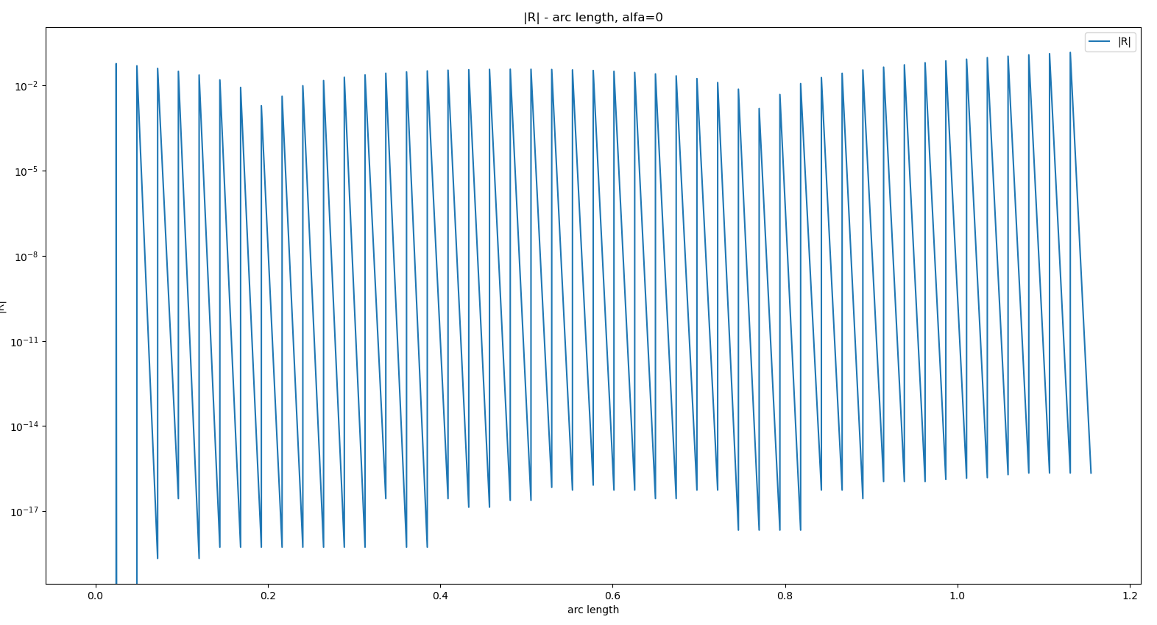

ALFA = 0.5

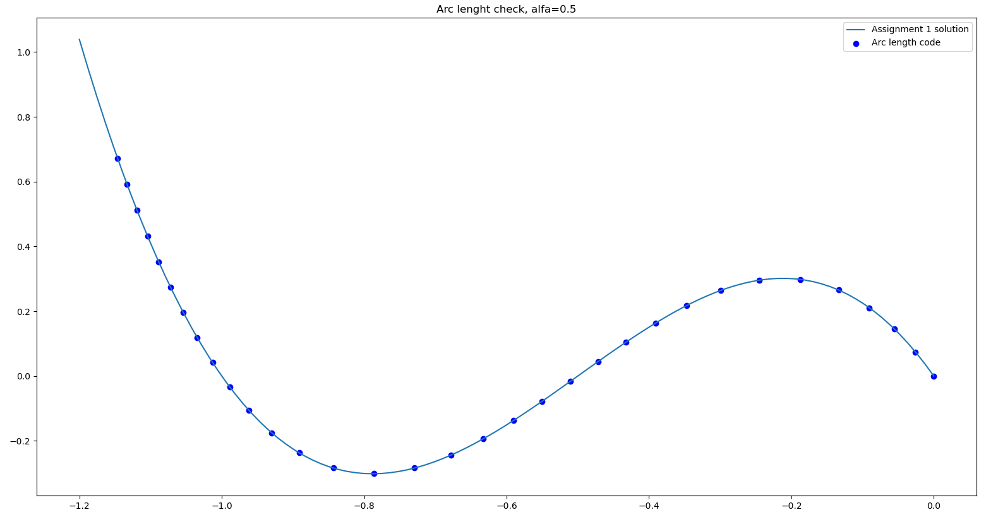

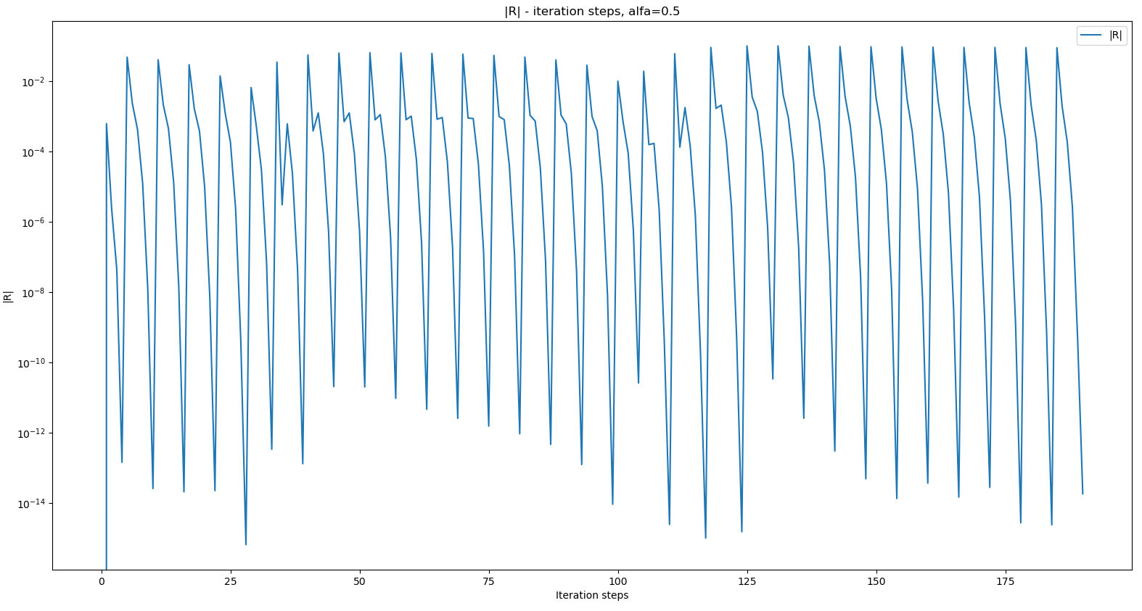

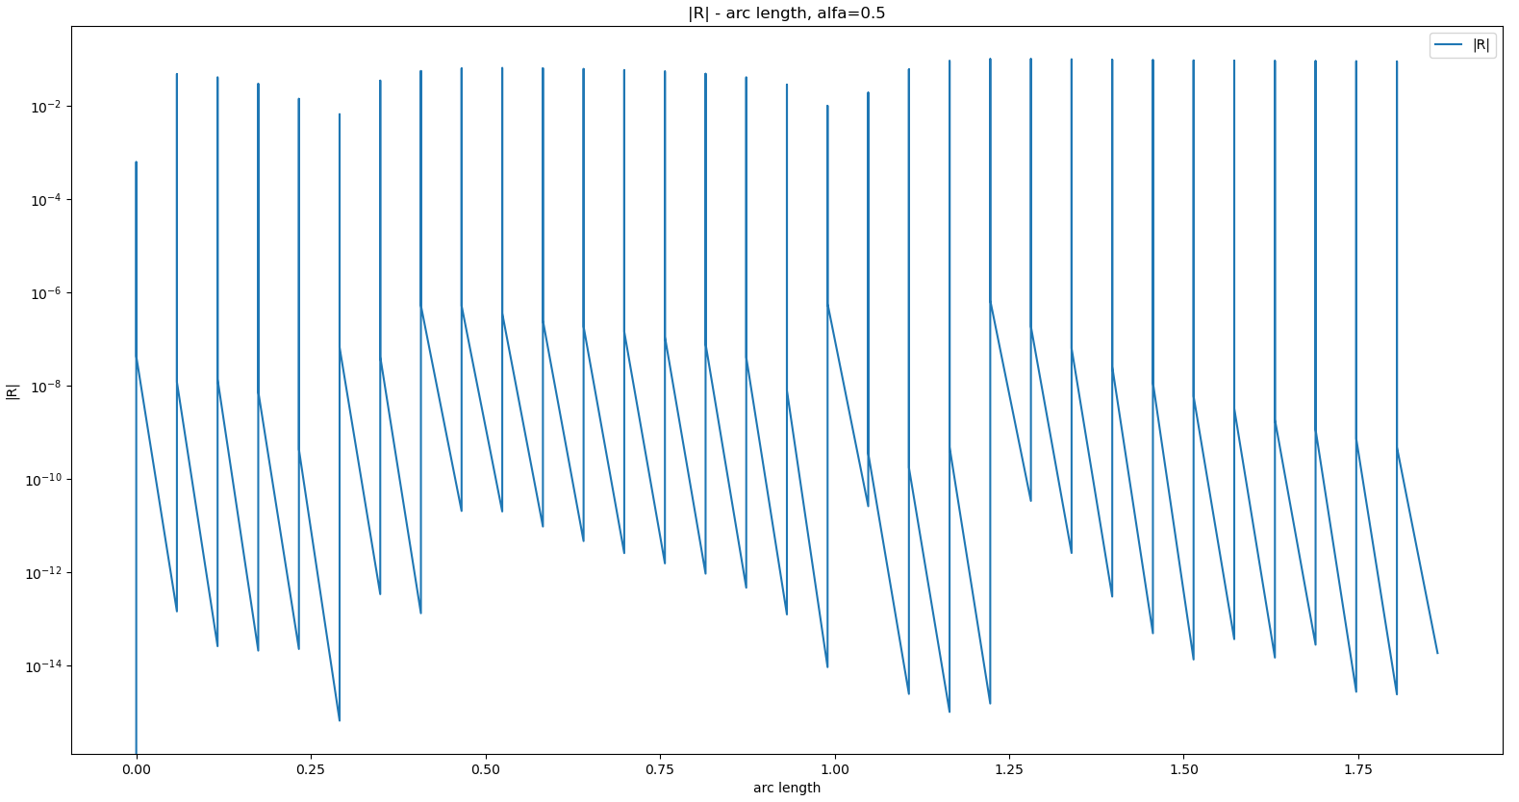

ALFA = 1.0

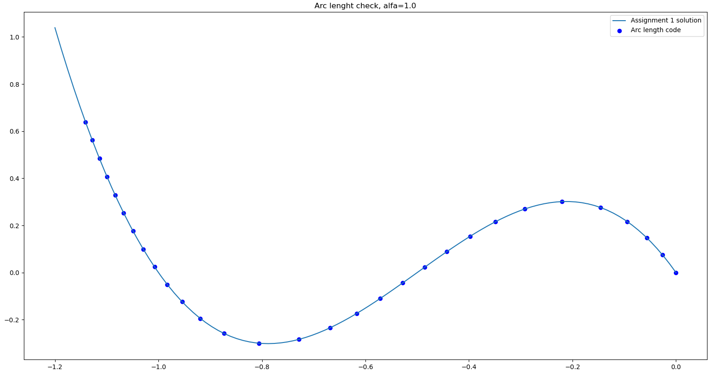

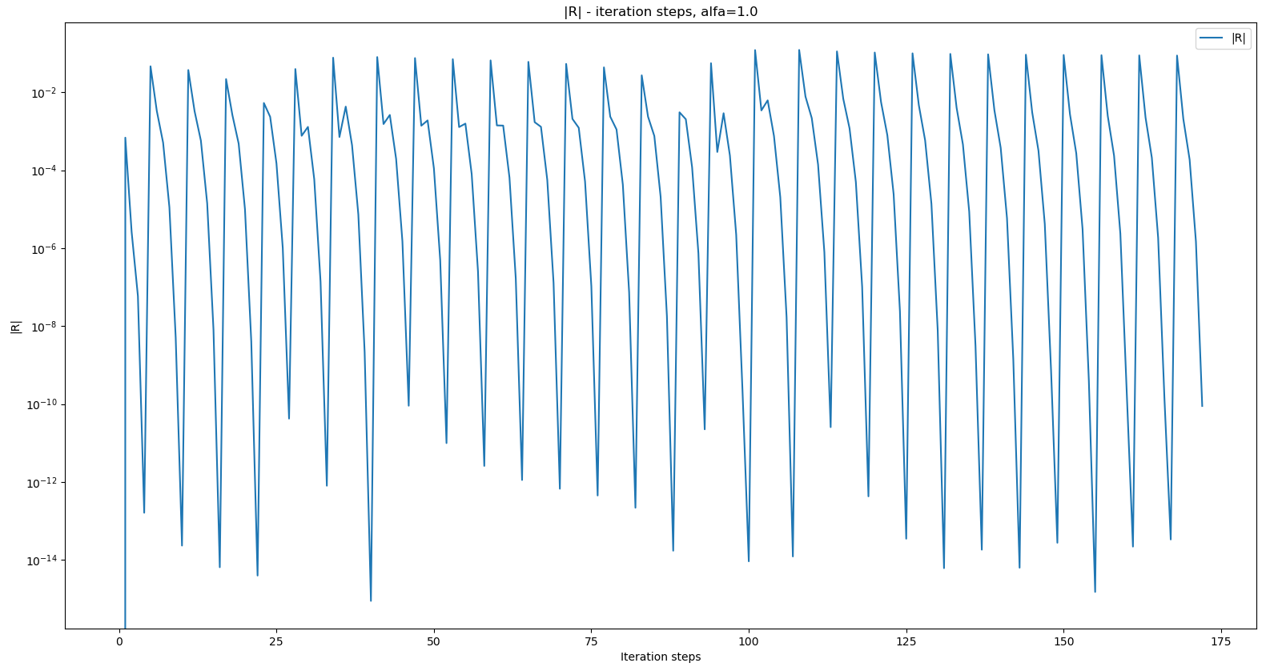

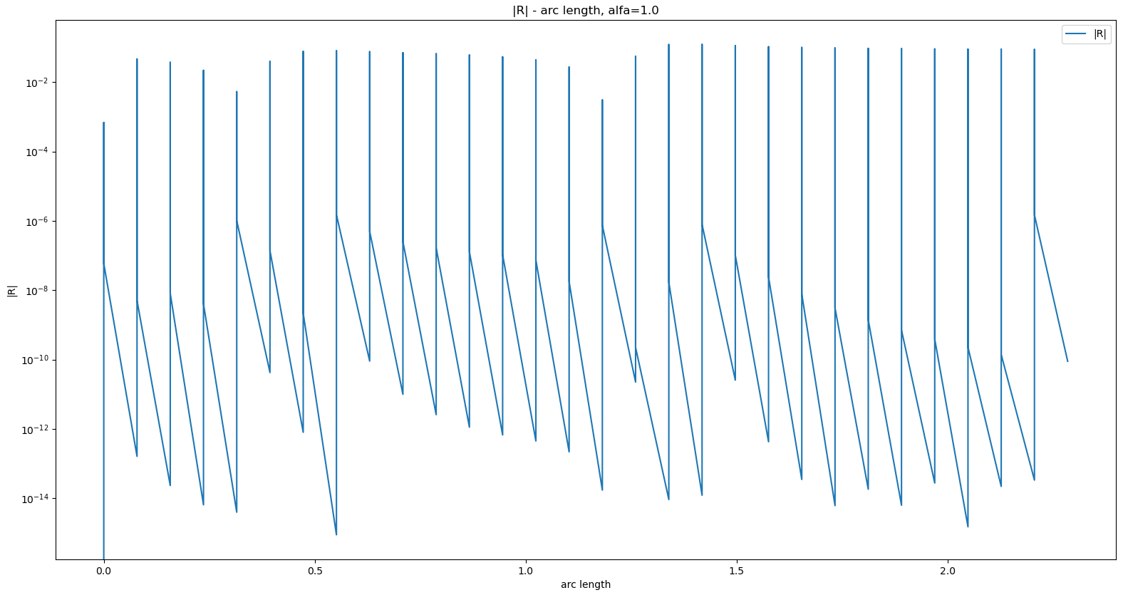

# Problem 2

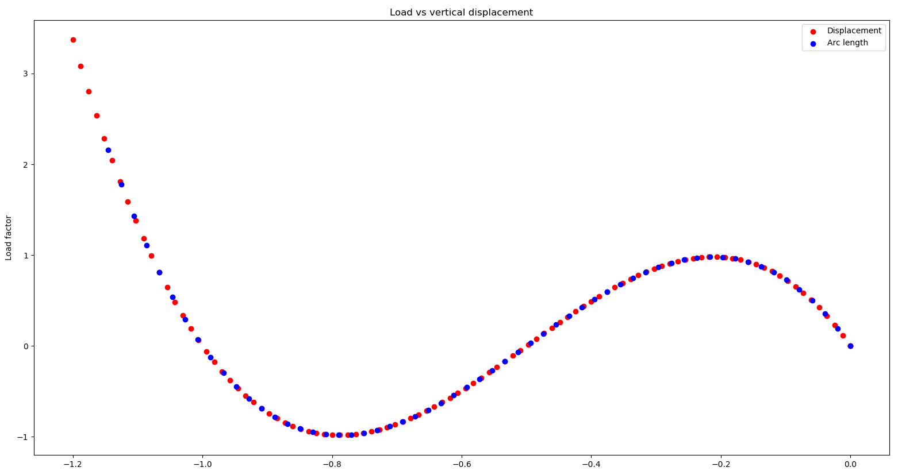

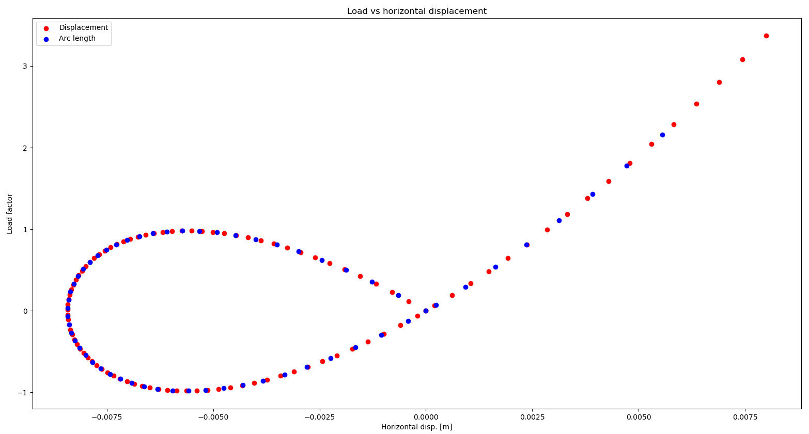

# Problem 3

Plot of structure

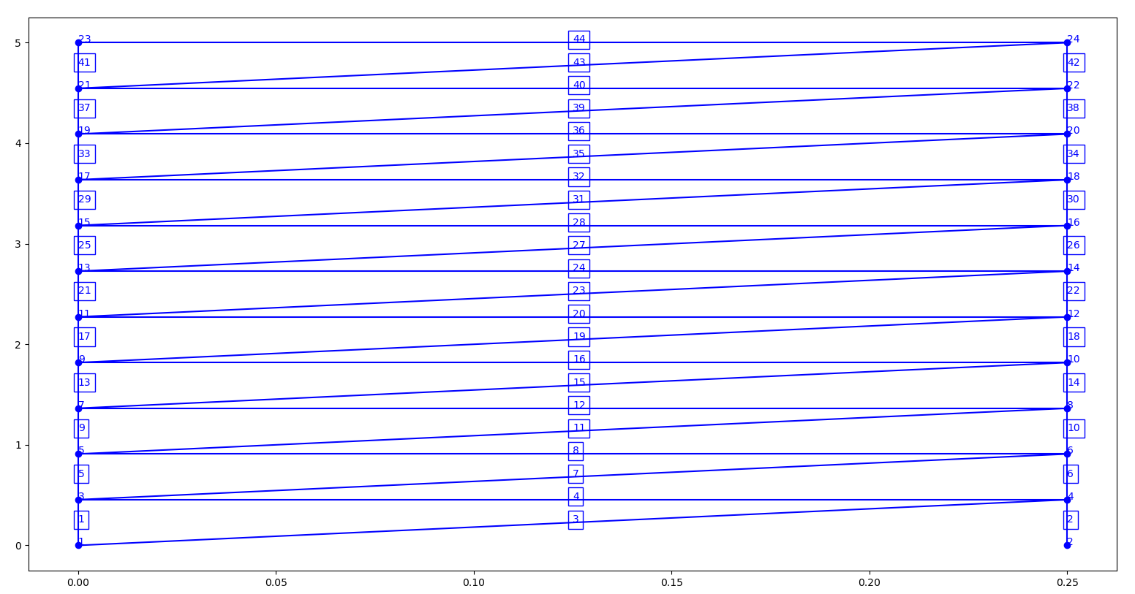

**Nodes**

[['no.' 'State' '[x, y, z]']

[1 array([0, 0]) array([0., 0.])]

[2 array([0, 0]) array([0.25, 0. ])]

[3 array([1, 1]) array([0. , 0.45454545])]

[4 array([1, 1]) array([0.25 , 0.45454545])]

[5 array([1, 1]) array([0. , 0.90909091])]

[6 array([1, 1]) array([0.25 , 0.90909091])]

[7 array([1, 1]) array([0. , 1.36363636])]

[8 array([1, 1]) array([0.25 , 1.36363636])]

[9 array([1, 1]) array([0. , 1.81818182])]

[10 array([1, 1]) array([0.25 , 1.81818182])]

[11 array([1, 1]) array([0. , 2.27272727])]

[12 array([1, 1]) array([0.25 , 2.27272727])]

[13 array([1, 1]) array([0. , 2.72727273])]

[14 array([1, 1]) array([0.25 , 2.72727273])]

[15 array([1, 1]) array([0. , 3.18181818])]

[16 array([1, 1]) array([0.25 , 3.18181818])]

[17 array([1, 1]) array([0. , 3.63636364])]

[18 array([1, 1]) array([0.25 , 3.63636364])]

[19 array([1, 1]) array([0. , 4.09090909])]

[20 array([1, 1]) array([0.25 , 4.09090909])]

[21 array([1, 1]) array([0. , 4.54545455])]

[22 array([1, 1]) array([0.25 , 4.54545455])]

[23 array([1, 1]) array([0., 5.])]

[24 array([1, 1]) array([0.25, 5. ])]]

**Elements**

[['no.' 'i-node' 'j-node' 'element']

[1 1 3 <truss.TrussElement object at 0x000001A77DD1C240>]

[2 2 4 <truss.TrussElement object at 0x000001A70D996EF0>]

[3 1 4 <truss.TrussElement object at 0x000001A70DBCE470>]

[4 3 4 <truss.TrussElement object at 0x000001A70DDB3D30>]

[5 3 5 <truss.TrussElement object at 0x000001A70D9E58D0>]

[6 4 6 <truss.TrussElement object at 0x000001A70D9E5128>]

[7 3 6 <truss.TrussElement object at 0x000001A70CCA0358>]

[8 5 6 <truss.TrussElement object at 0x000001A70CC9AEF0>]

[9 5 7 <truss.TrussElement object at 0x000001A70DF13860>]

[10 6 8 <truss.TrussElement object at 0x000001A70DF13898>]

[11 5 8 <truss.TrussElement object at 0x000001A70DF138D0>]

[12 7 8 <truss.TrussElement object at 0x000001A70DF13908>]

[13 7 9 <truss.TrussElement object at 0x000001A70DF139B0>]

[14 8 10 <truss.TrussElement object at 0x000001A70DF13C50>]

[15 7 10 <truss.TrussElement object at 0x000001A70DF13C88>]

[16 9 10 <truss.TrussElement object at 0x000001A70DF13CC0>]

[17 9 11 <truss.TrussElement object at 0x000001A70DF13CF8>]

[18 10 12 <truss.TrussElement object at 0x000001A70DF13D30>]

[19 9 12 <truss.TrussElement object at 0x000001A70DF13D68>]

[20 11 12 <truss.TrussElement object at 0x000001A70DF13DA0>]

[21 11 13 <truss.TrussElement object at 0x000001A70DF13DD8>]

[22 12 14 <truss.TrussElement object at 0x000001A70DF13E10>]

[23 11 14 <truss.TrussElement object at 0x000001A70DF13E48>]

[24 13 14 <truss.TrussElement object at 0x000001A70DF13E80>]

[25 13 15 <truss.TrussElement object at 0x000001A70DF13EB8>]

[26 14 16 <truss.TrussElement object at 0x000001A70DF13EF0>]

[27 13 16 <truss.TrussElement object at 0x000001A70DF13F28>]

[28 15 16 <truss.TrussElement object at 0x000001A70DF13F60>]

[29 15 17 <truss.TrussElement object at 0x000001A70DF13F98>]

[30 16 18 <truss.TrussElement object at 0x000001A70DF13FD0>]

[31 15 18 <truss.TrussElement object at 0x000001A70DC74E48>]

[32 17 18 <truss.TrussElement object at 0x000001A70DF2D048>]

[33 17 19 <truss.TrussElement object at 0x000001A70DF2D080>]

[34 18 20 <truss.TrussElement object at 0x000001A70DF2D0B8>]

[35 17 20 <truss.TrussElement object at 0x000001A70DF2D0F0>]

[36 19 20 <truss.TrussElement object at 0x000001A70DF2D128>]

[37 19 21 <truss.TrussElement object at 0x000001A70DF2D160>]

[38 20 22 <truss.TrussElement object at 0x000001A70DF2D198>]

[39 19 22 <truss.TrussElement object at 0x000001A70DF2D1D0>]

[40 21 22 <truss.TrussElement object at 0x000001A70DF2D208>]

[41 21 23 <truss.TrussElement object at 0x000001A70DF2D240>]

[42 22 24 <truss.TrussElement object at 0x000001A70DF2D278>]

[43 21 24 <truss.TrussElement object at 0x000001A70DF2D2B0>]

[44 23 24 <truss.TrussElement object at 0x000001A70DF2D2E8>]]

## Part 2

Estimated P.cr = 6.1685 kN

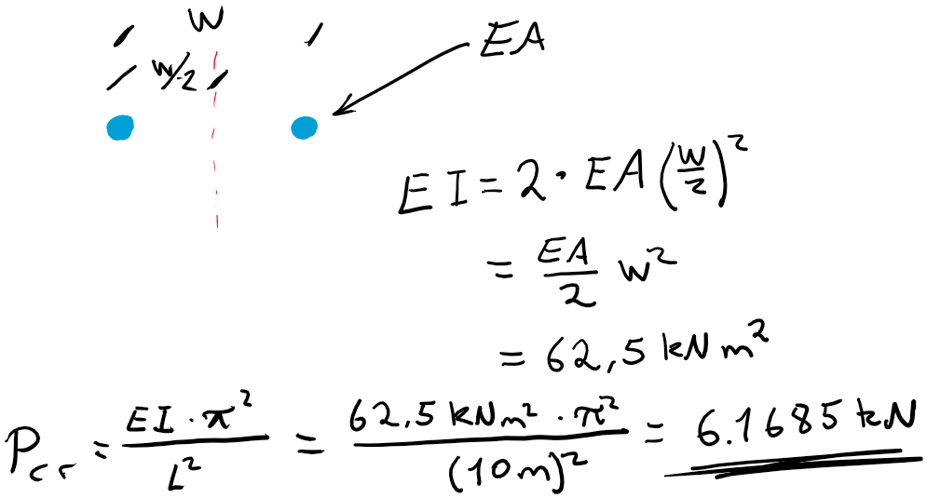

## Part 3

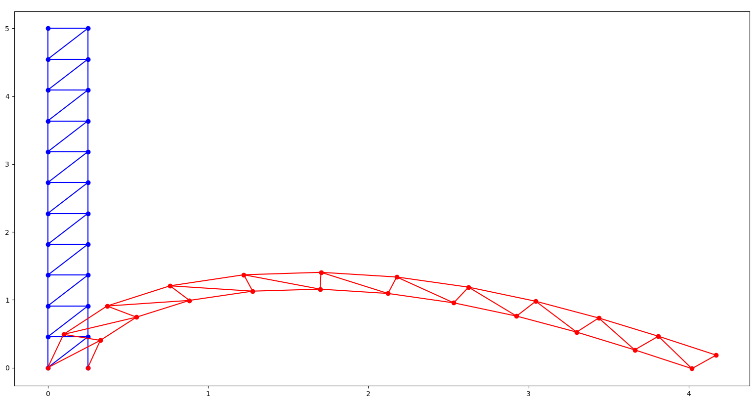

## Part 4

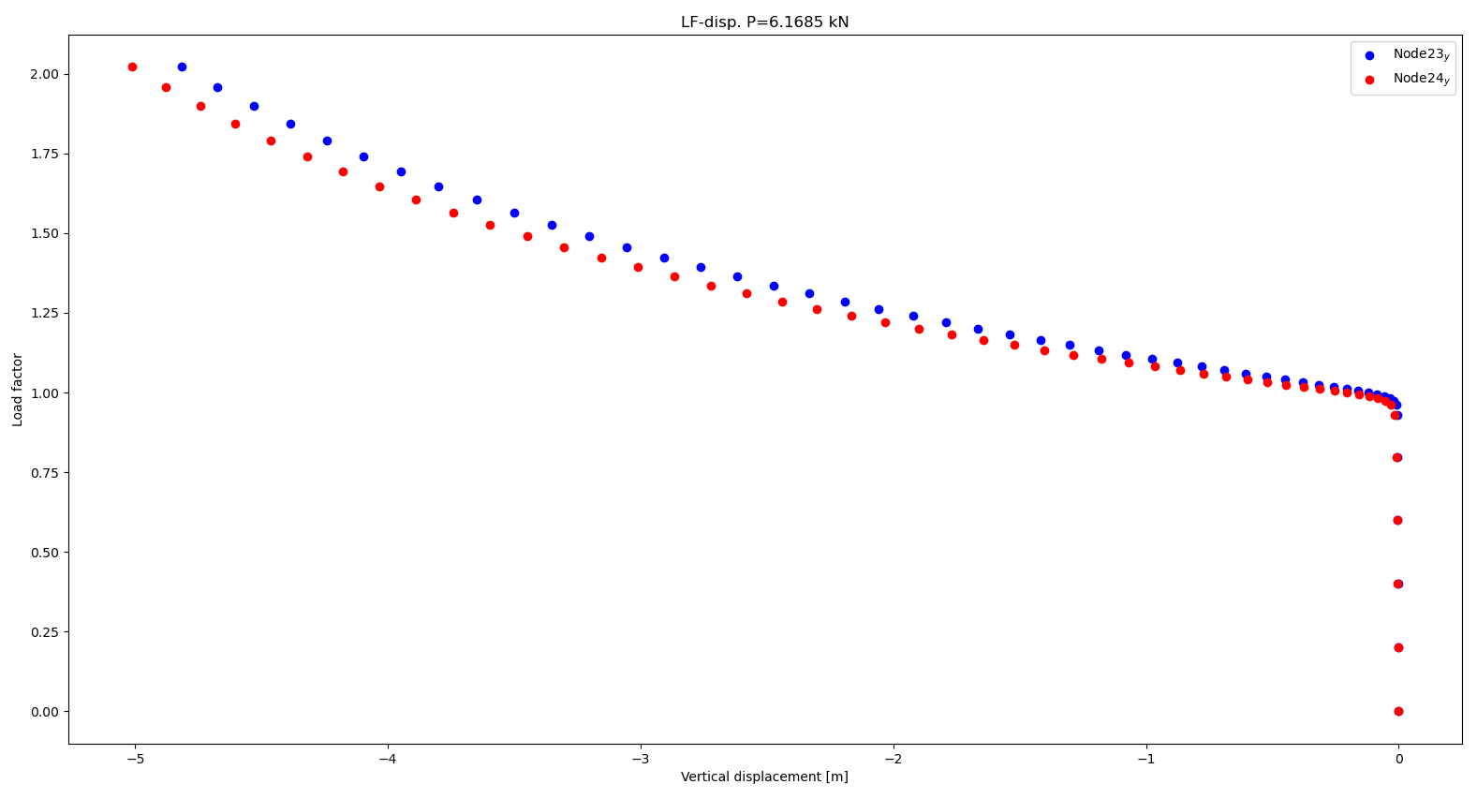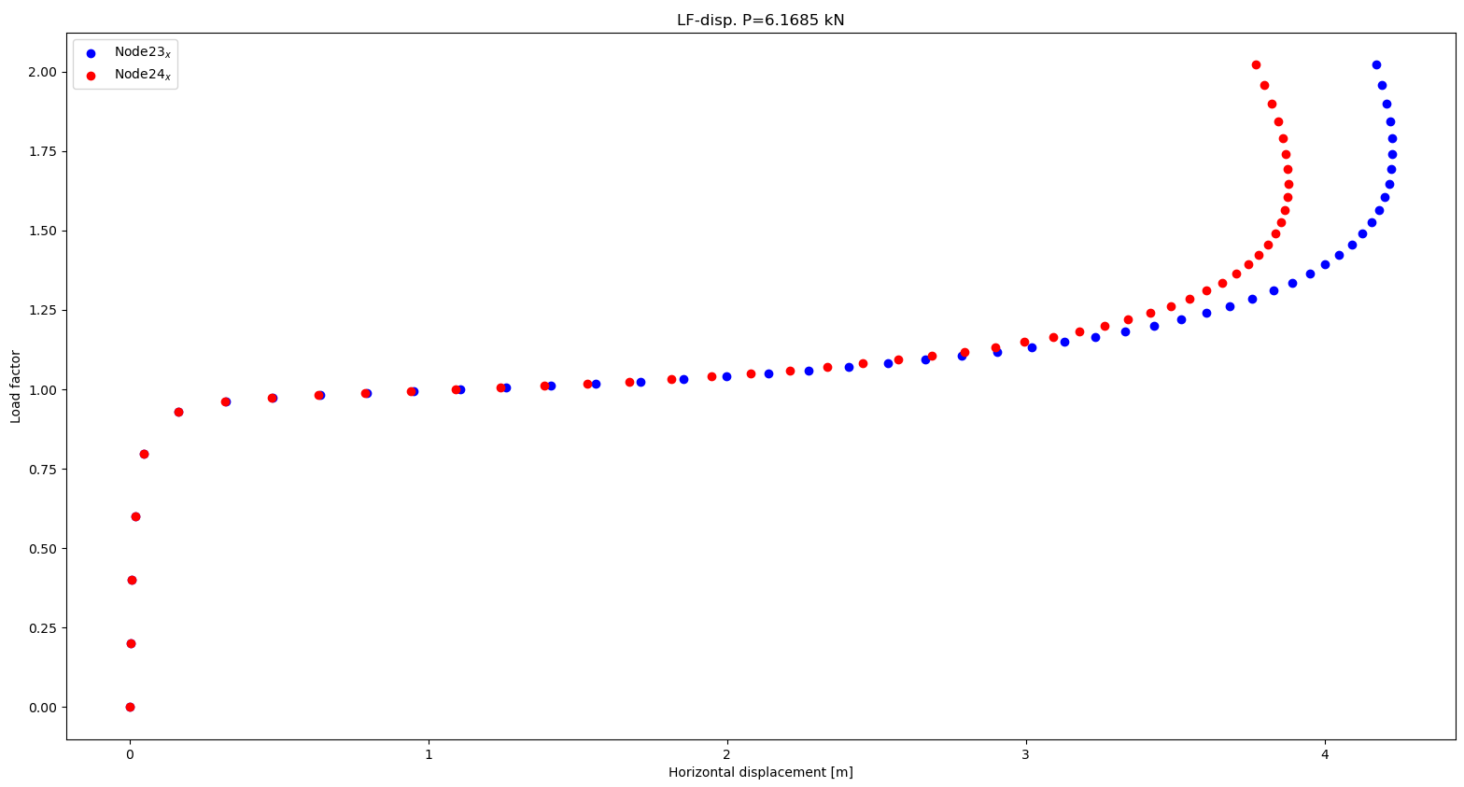

## Part 5

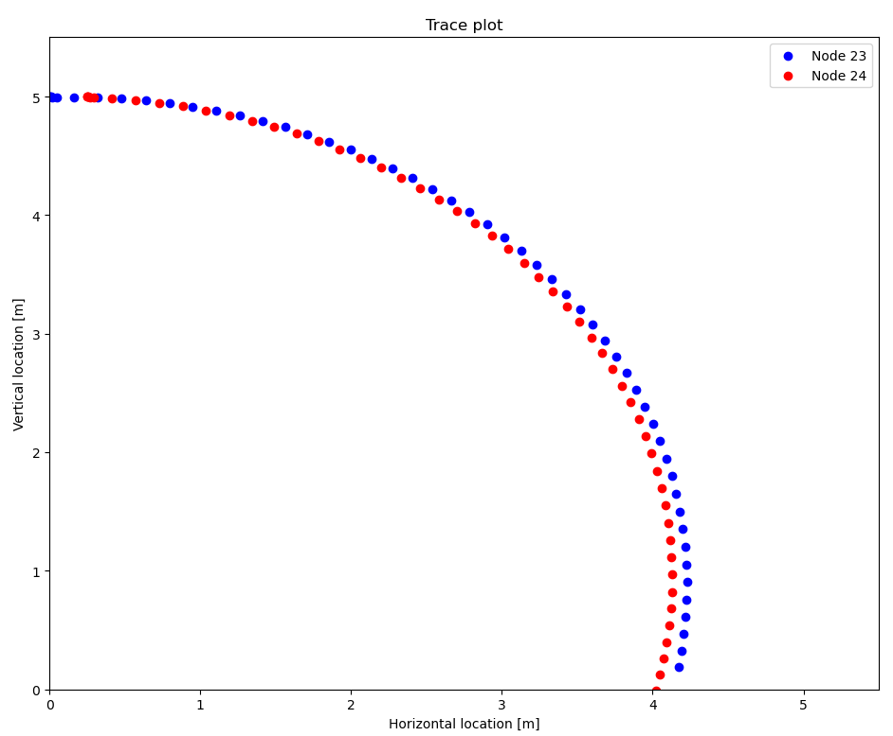

## Part 6 – Deflected structure

